**Subject:** **AZCC-MINOR-OCT**

**Name:Niranjan Rajendra Chavan**

**Email:chavanniranjan8@gmail.com Phone No-9822165708**

**Vnet1**

Step1:Creating Vnet1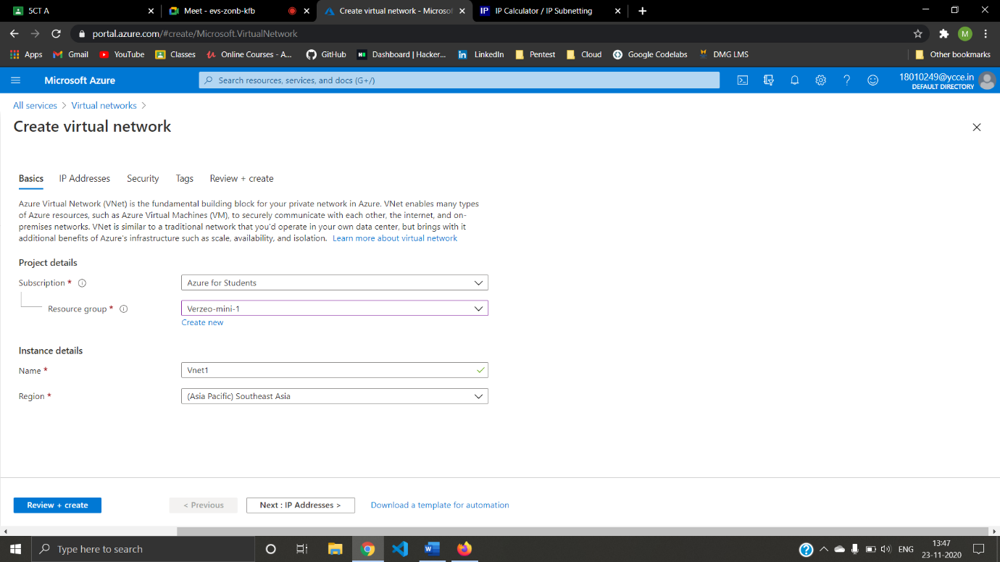(10.0.0.0/16)

Step2:creating Subnet For Vnet1(verzmini_SN01(10.0.0.0/24) and verzmini_SN02(10.0.1.0/24))

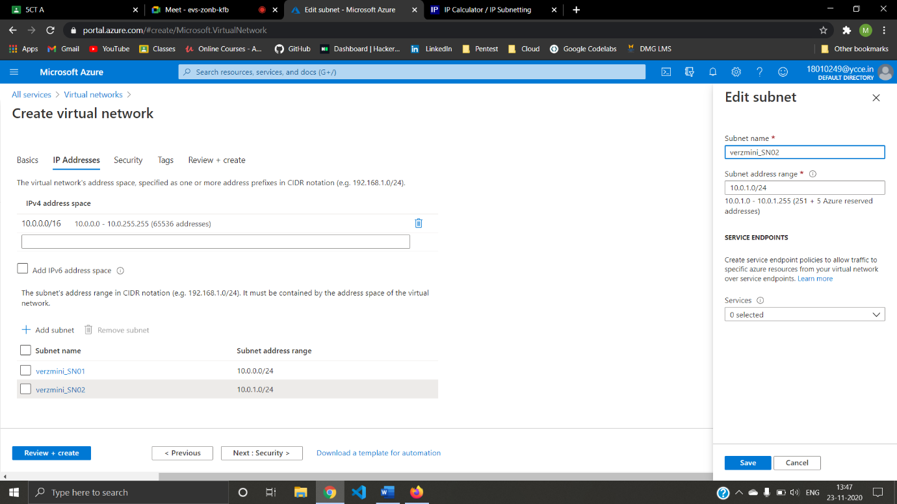

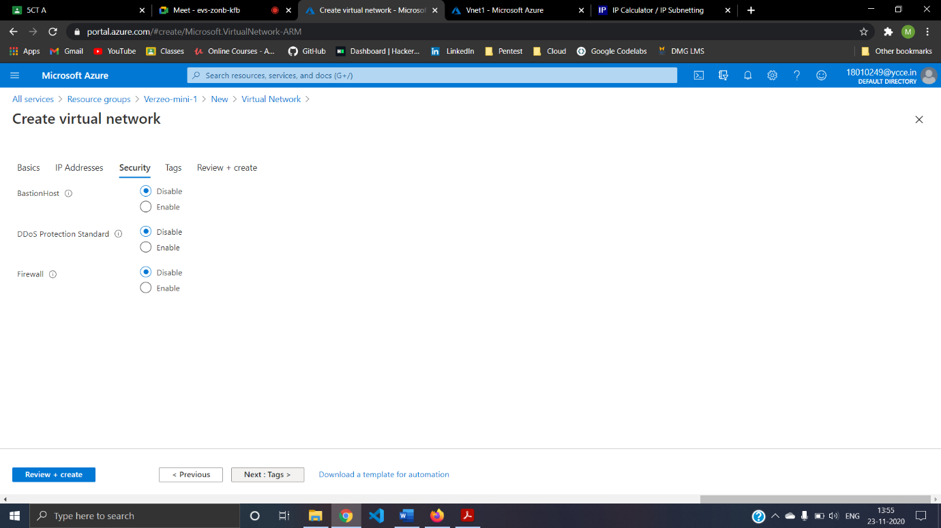Step03:Security For Vnet1

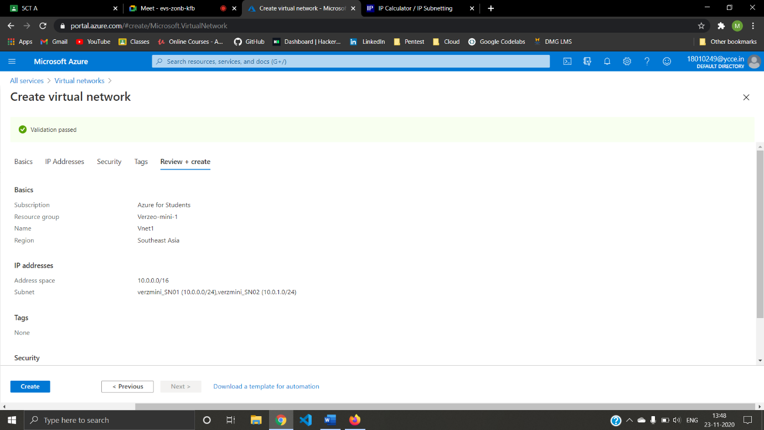Step04:Final step for Vnet1

**Vnet2**

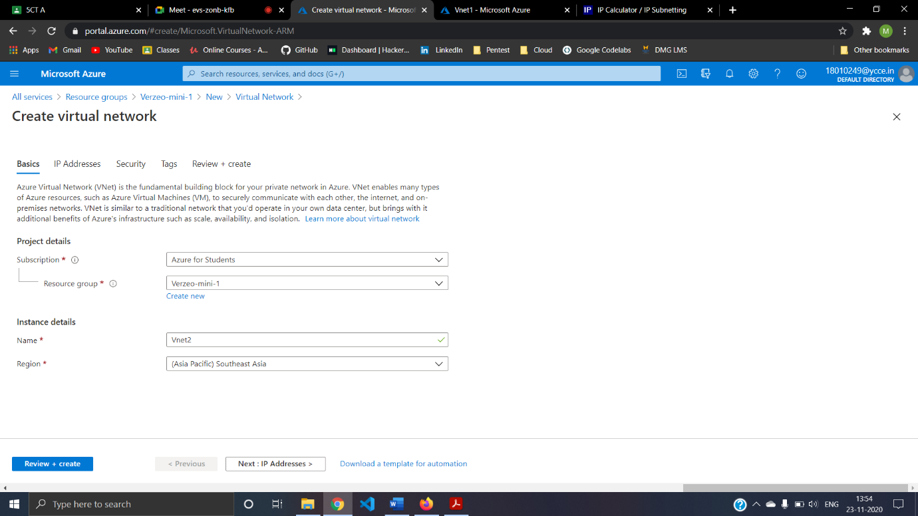Step05: Creating Vnet2 (10.1.0.0/16)

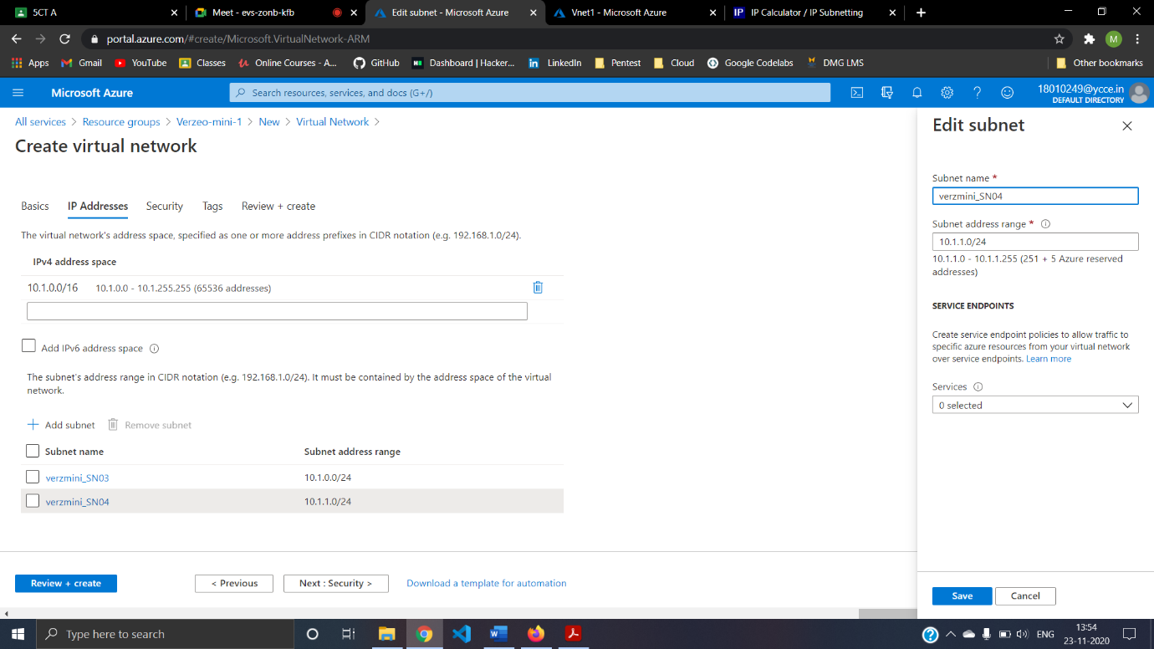Step06:creating Subnet For Vnet1(verzmini_SN03(10.1.0.0/24) and verzmini_SN04(10.1.1.0/24))

Step07:Security For Vt2

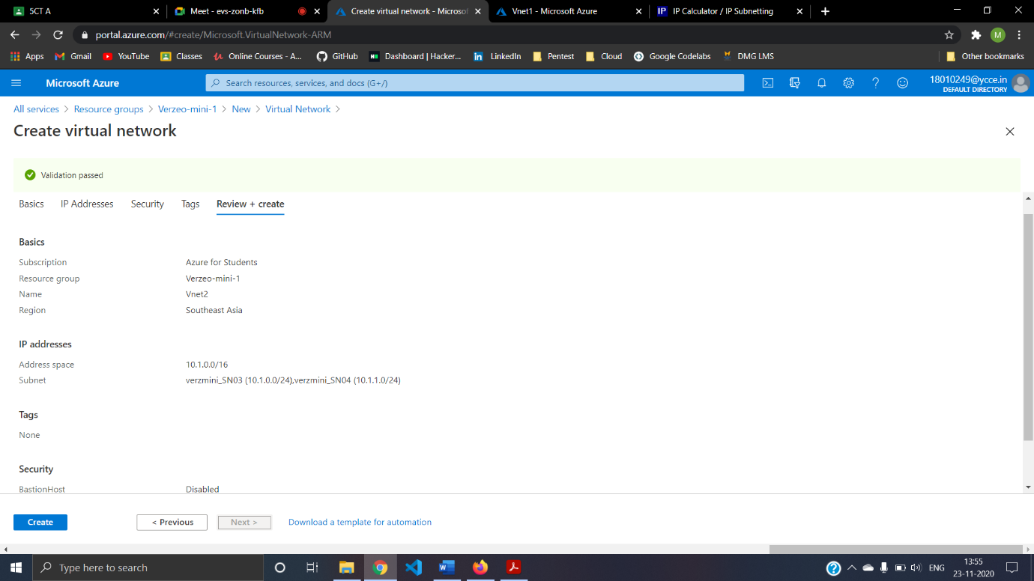Step08:Finish step for Vnet2

**VM1**

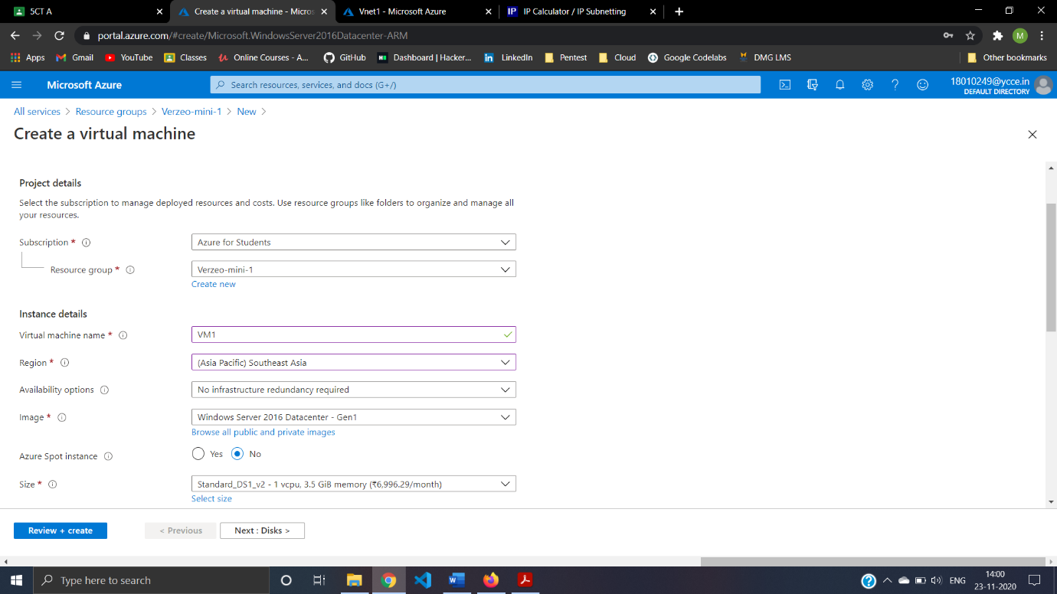Step09:Creating VM1

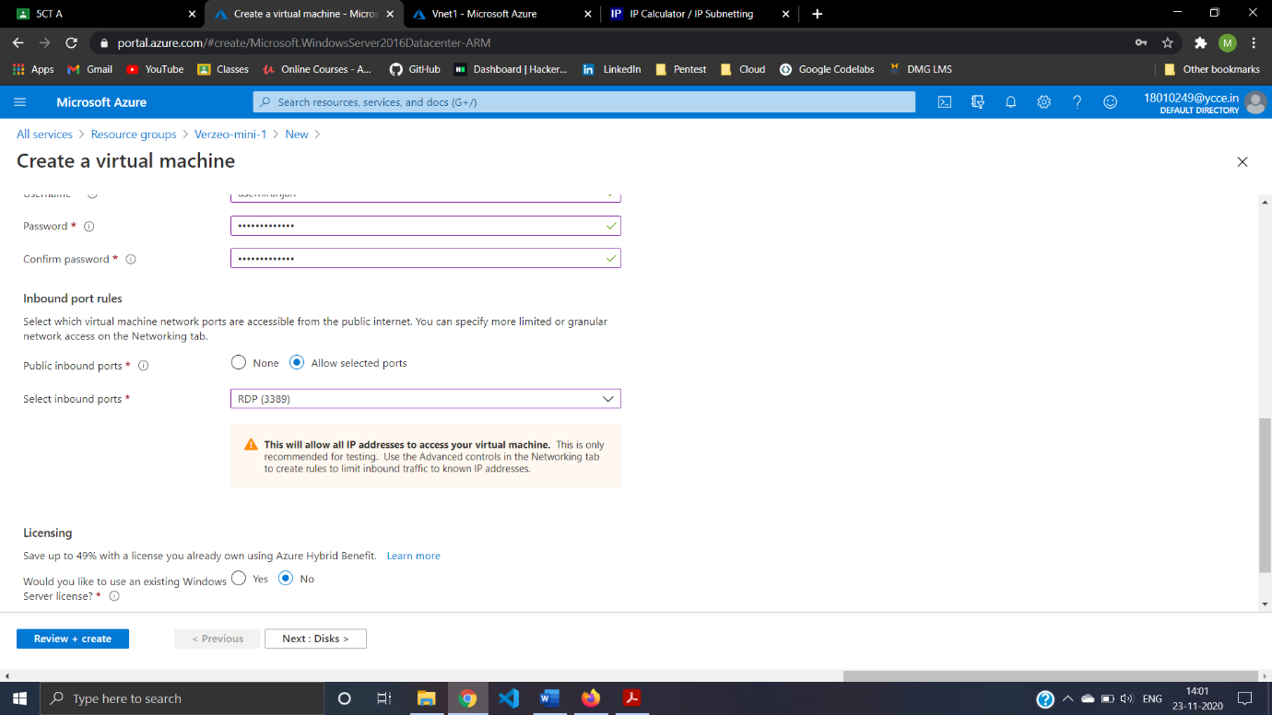Step10:Configure Inbound ports

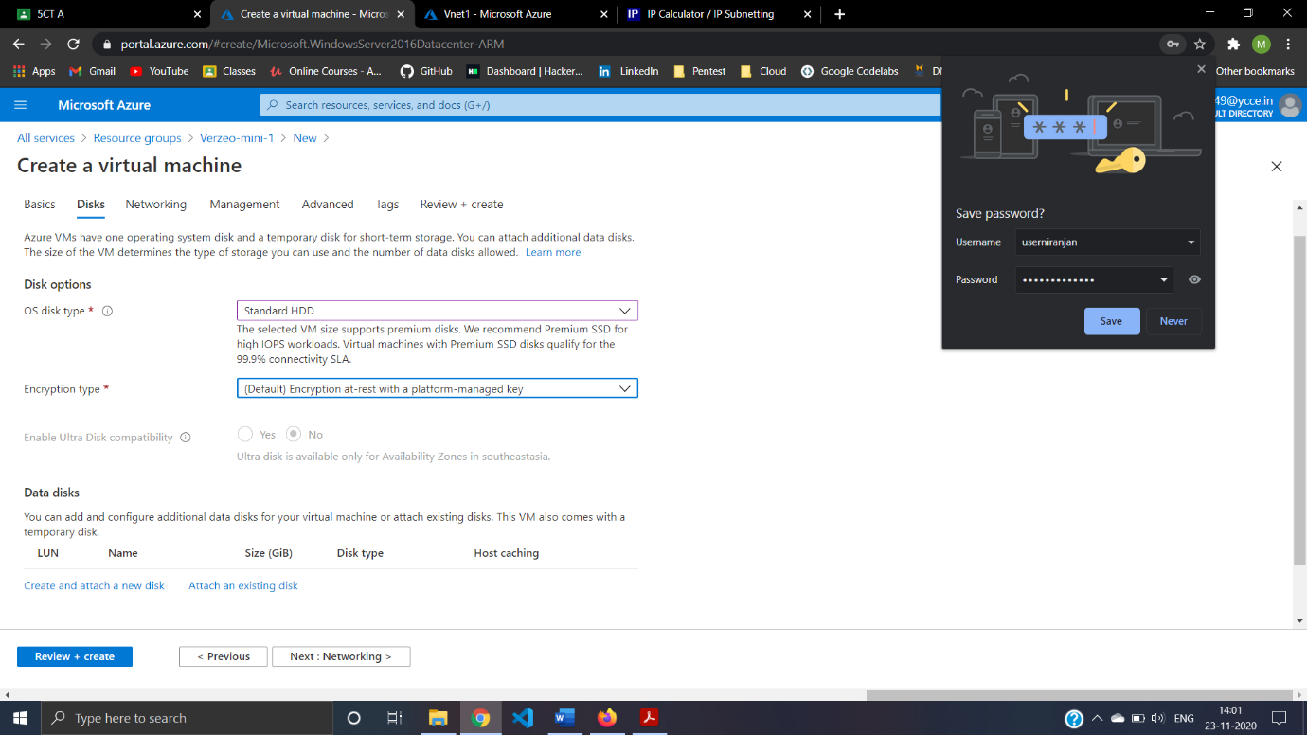Step11:Configuring Disk For VM1

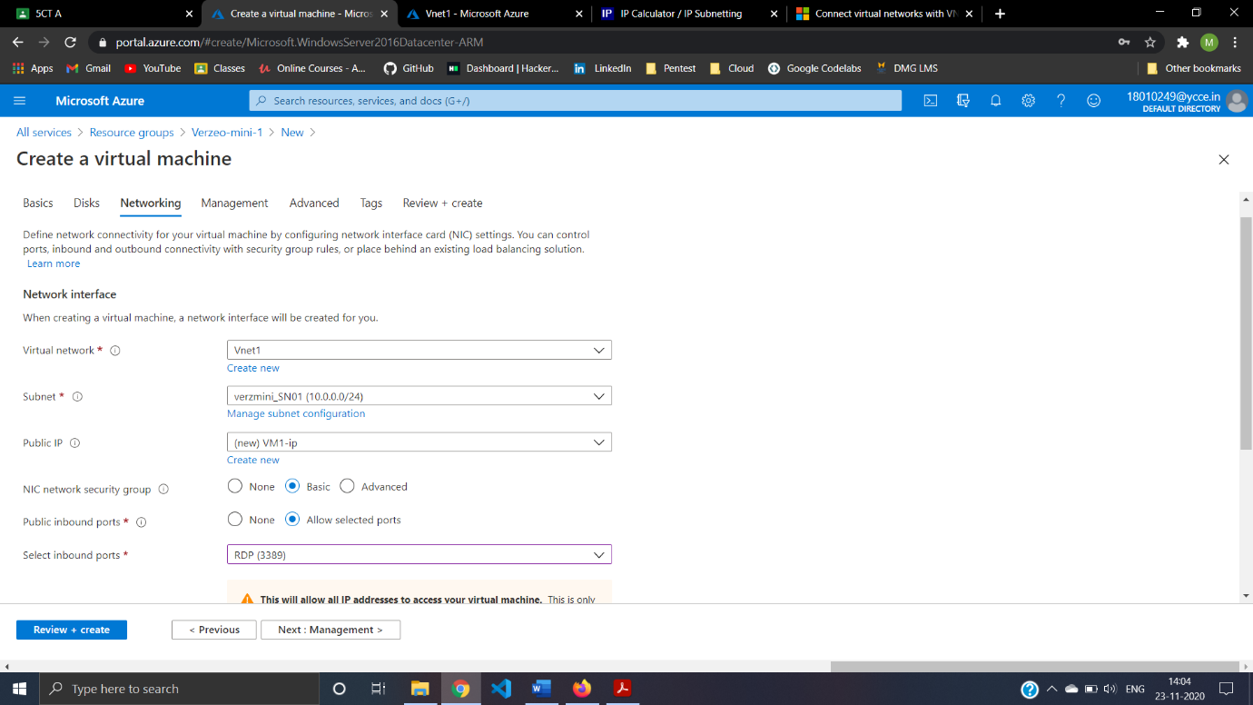Step12:VM1 Networking in Vnet1 and Subnet Verzmini_SN01(10.0.0.0/24) And Assign Public IP.

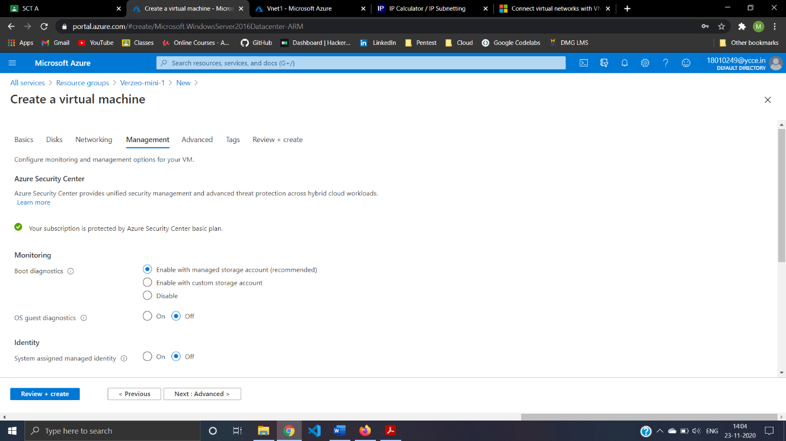Step13:Public Inbound Port Configuration for VM1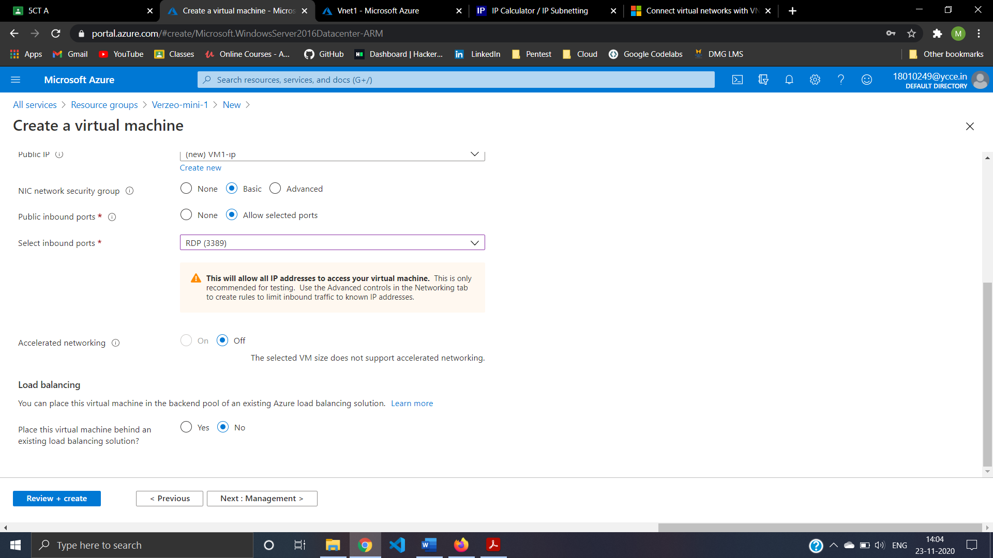

Step14:Management For VM1

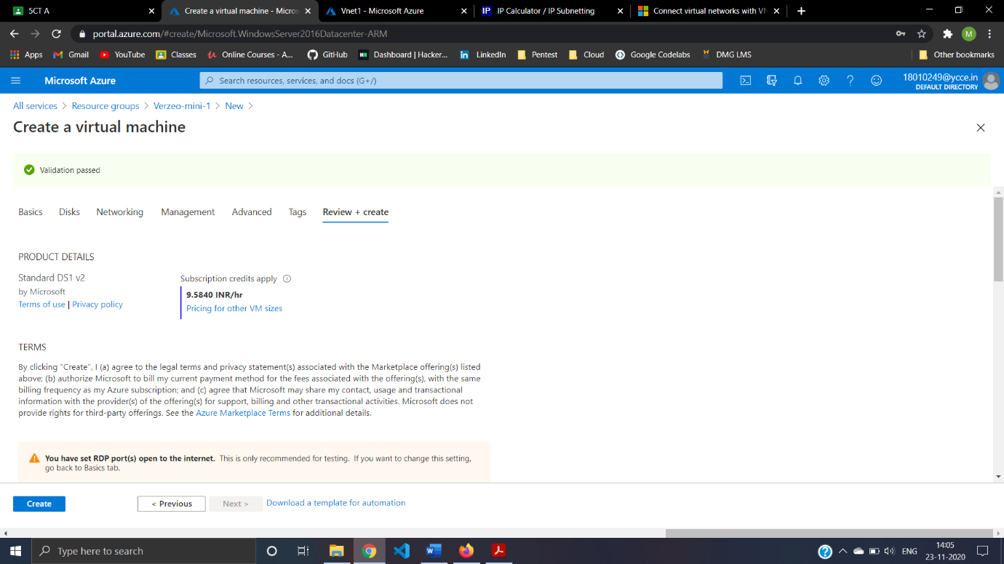Step15:Review and Create VM1

**VM2**

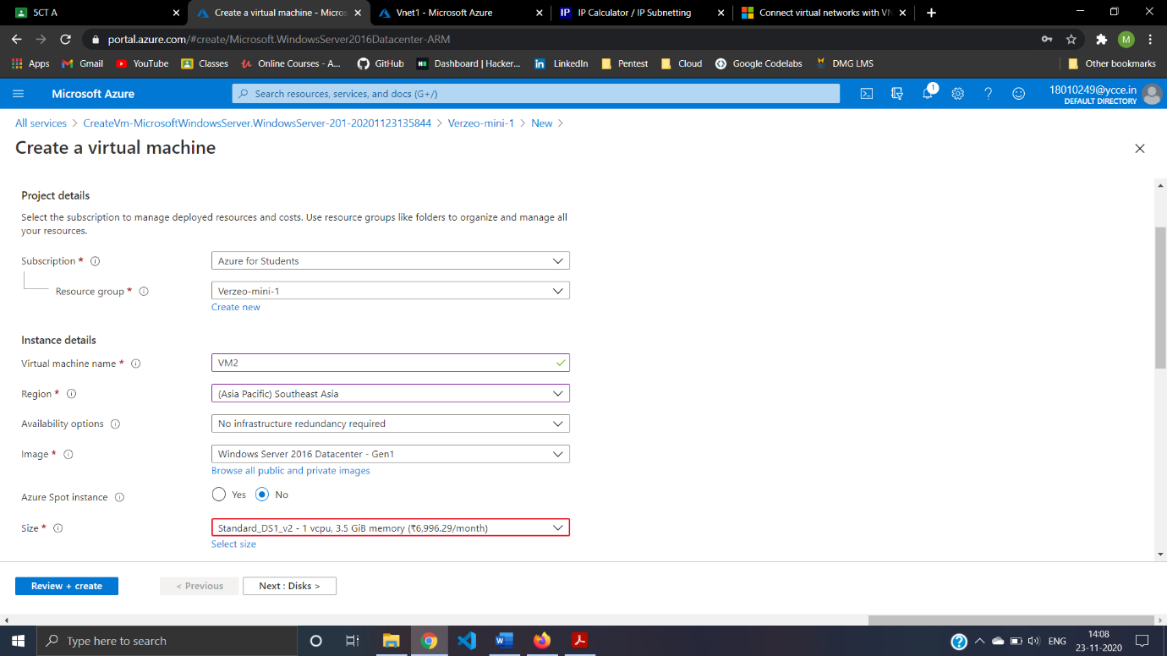Step16: Creating VM2

Step17: Configure Inbound ports For VM2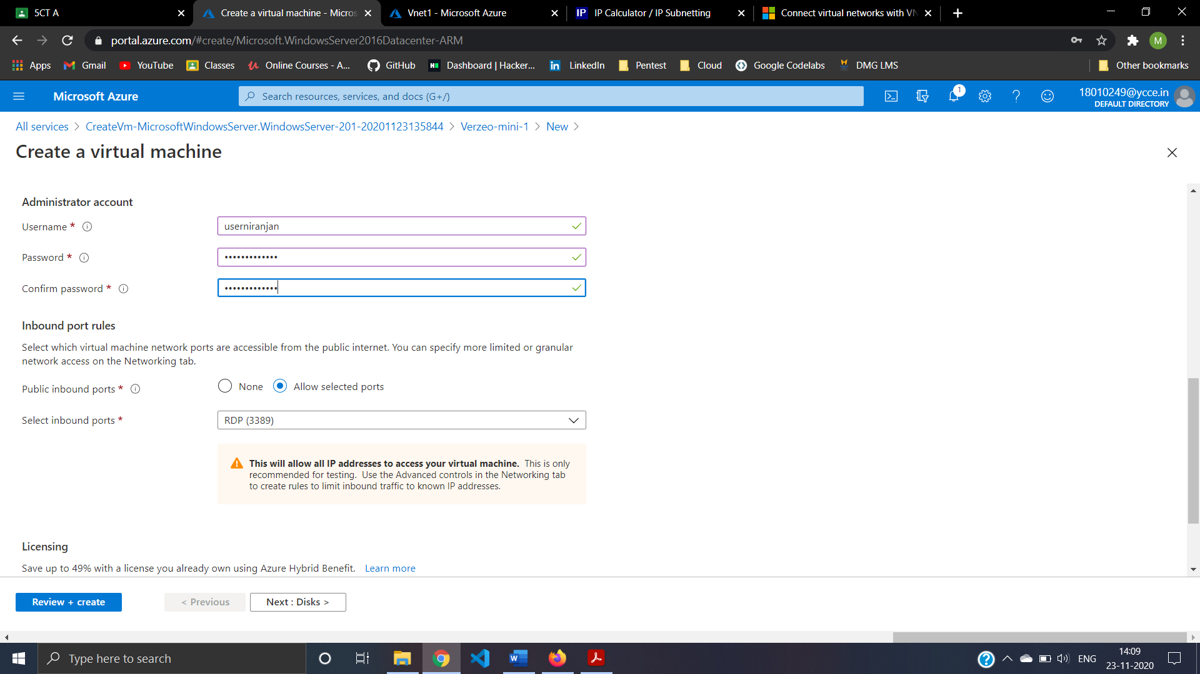

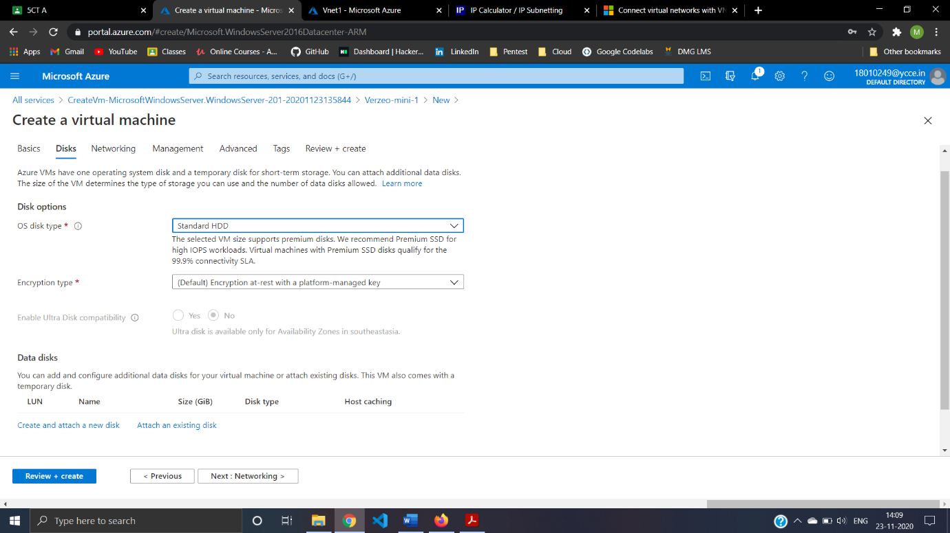Step18: Configuring Disk For VM2

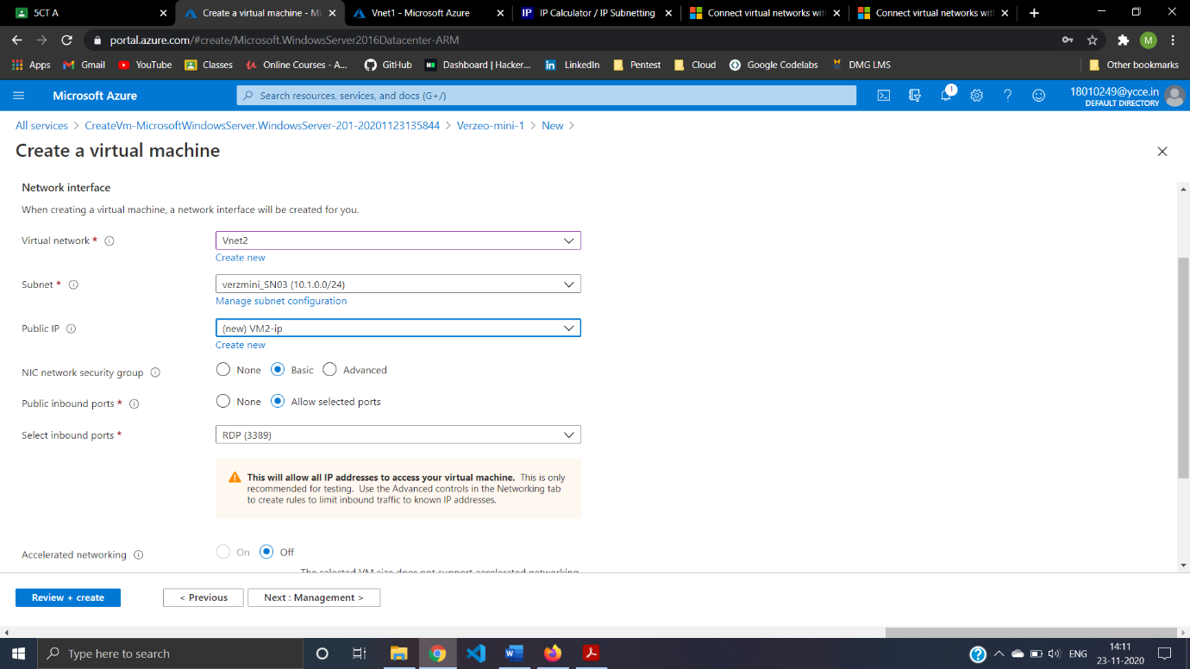Step19: VM2 Networking in Vnet2 and Subnet Verzmini_SN03(10.1.0.0/24) And Assign Public IP.

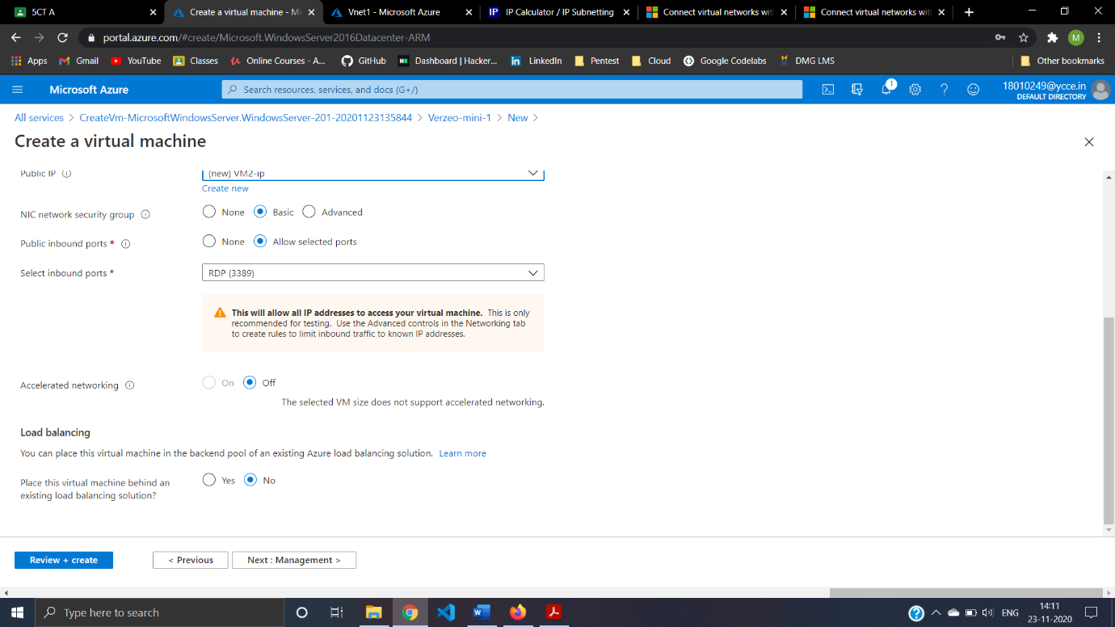Step20: Public Inbound Port Configuration for VM2

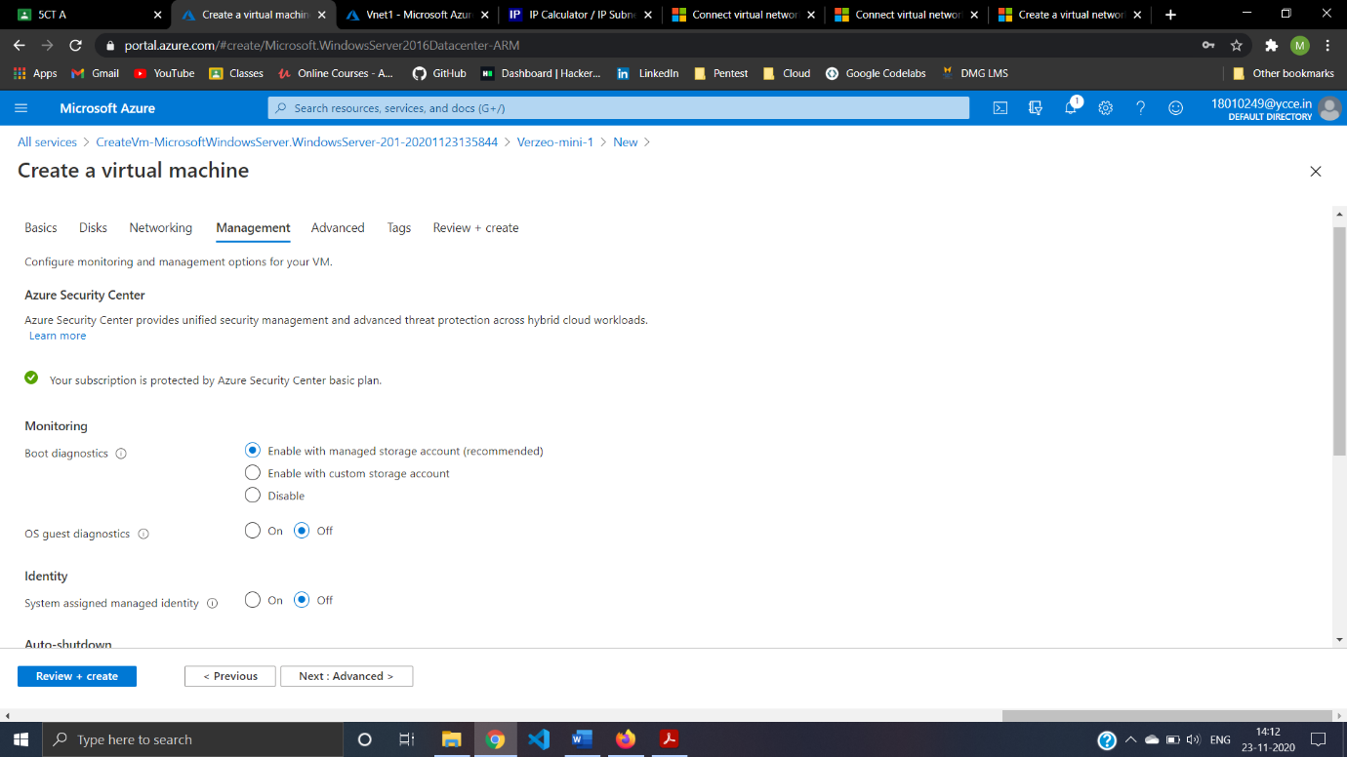Step21:Management For VM2

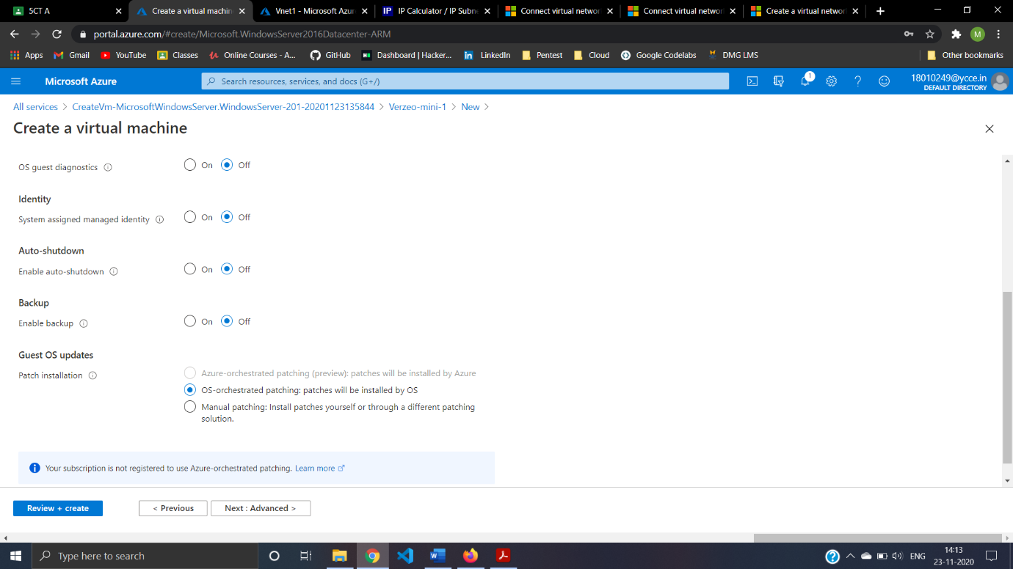Step22:Advanced setting For VM2

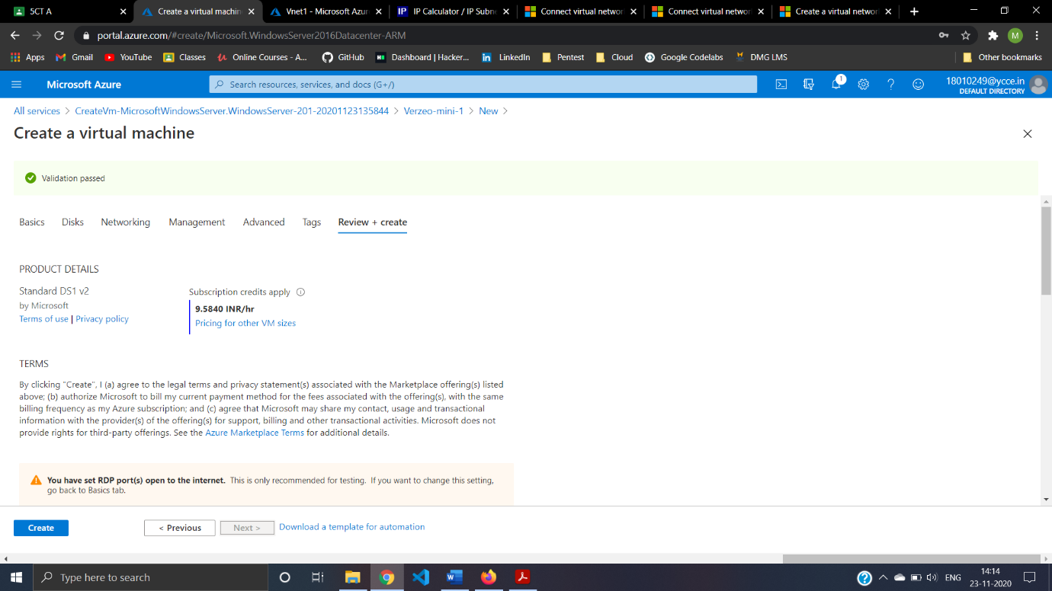Step23: Review and Create VM2

**Peering**

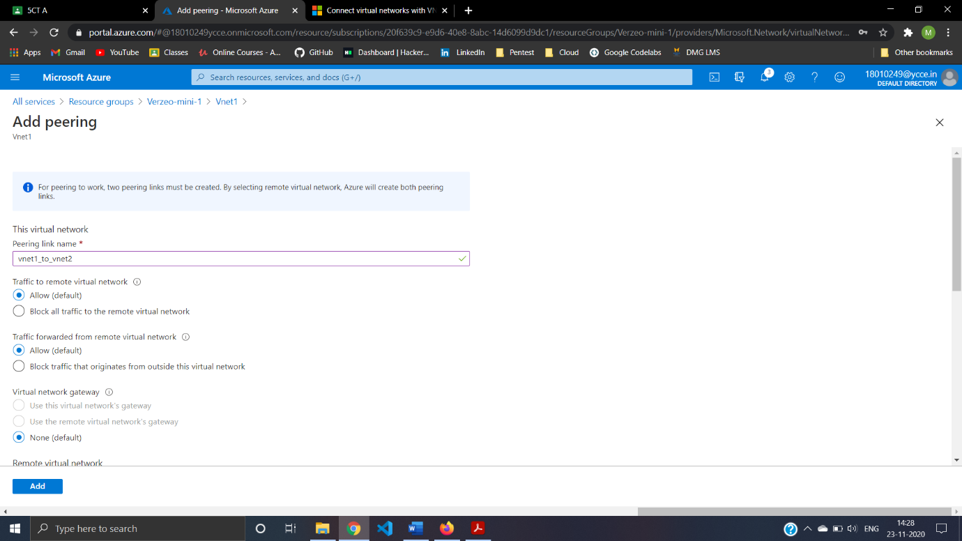Step24:Add peering To Vnet1 And Vnet2.Creating Peering

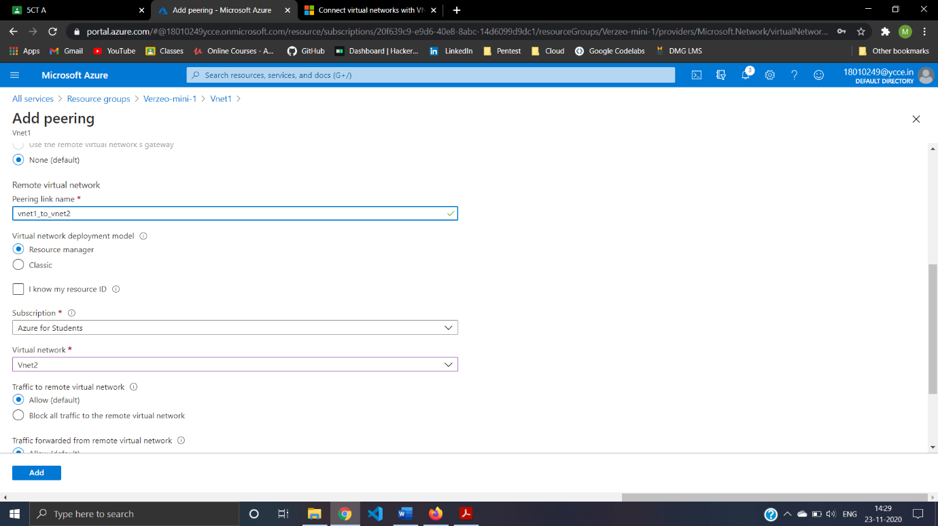Step25:Configuring The Peering In Vnet1 to Vnet2

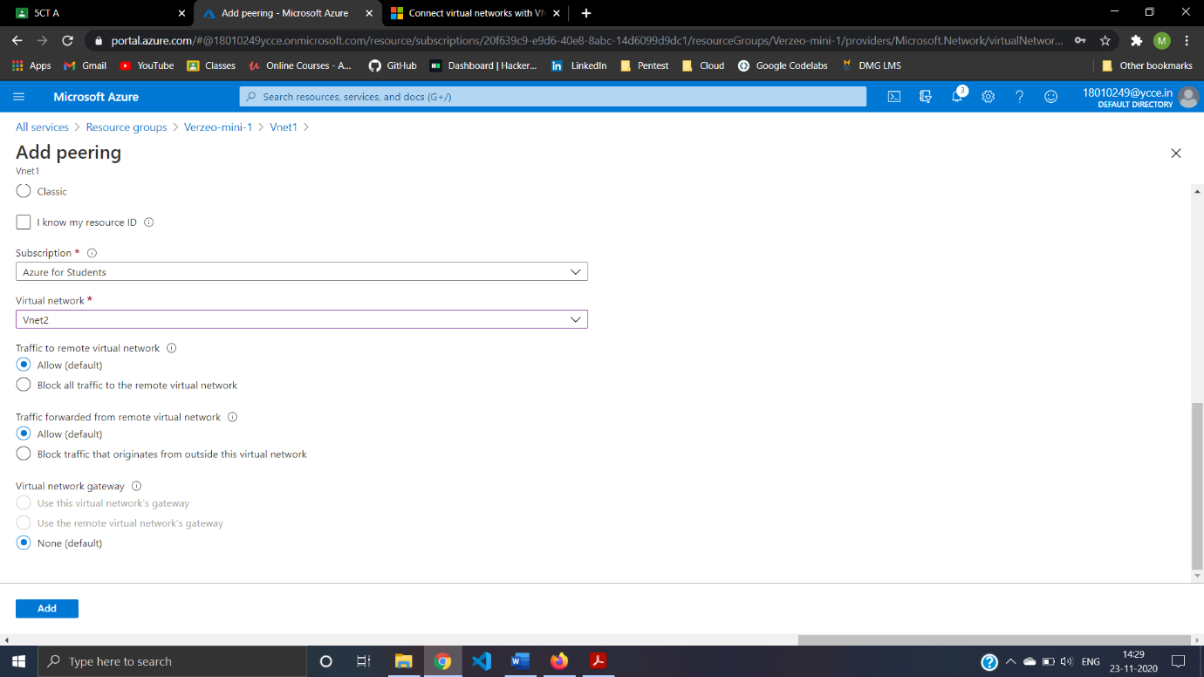Step26:Traffic to vnet peering.

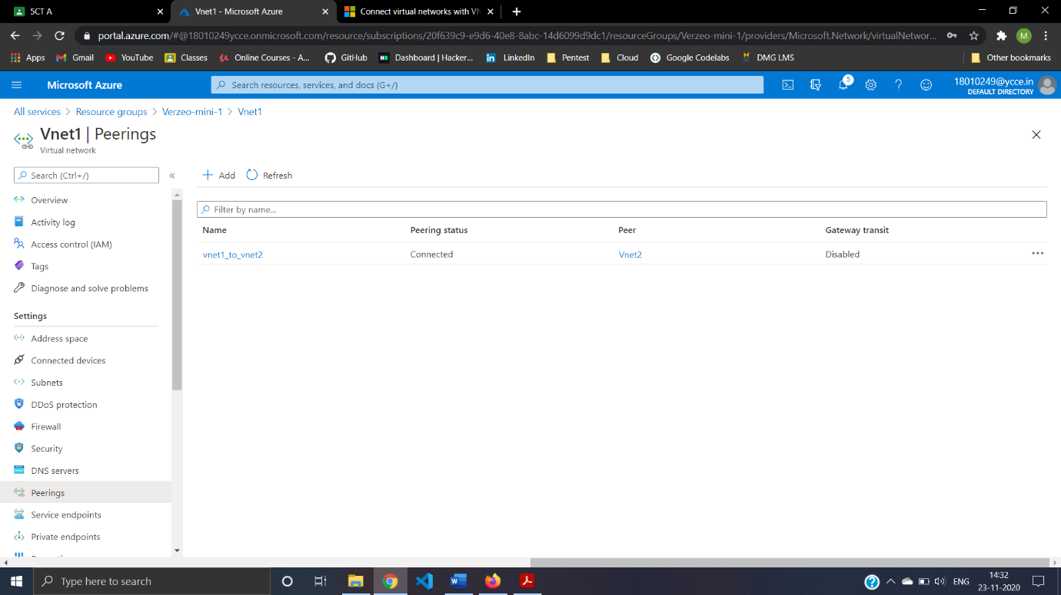Step27:Done with Peering

**Connect To VM**

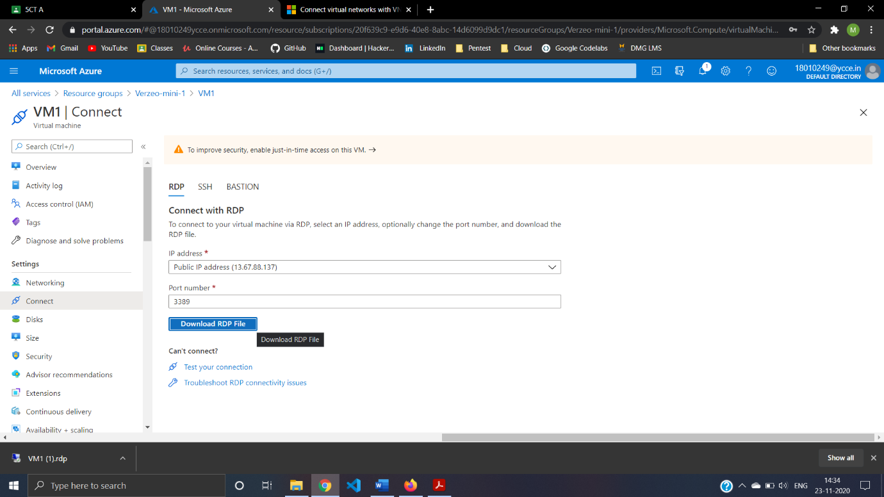Step28:Downloading RDP File.

Step29:After using RDP file and Remote Desktop.login in VM1

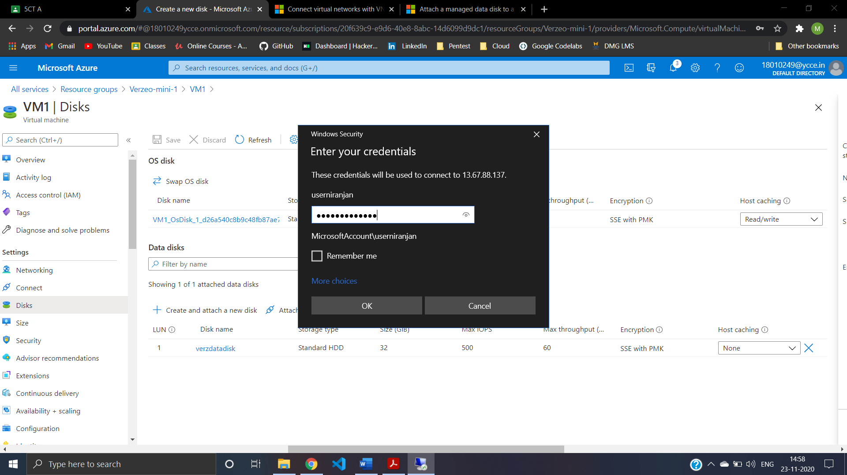

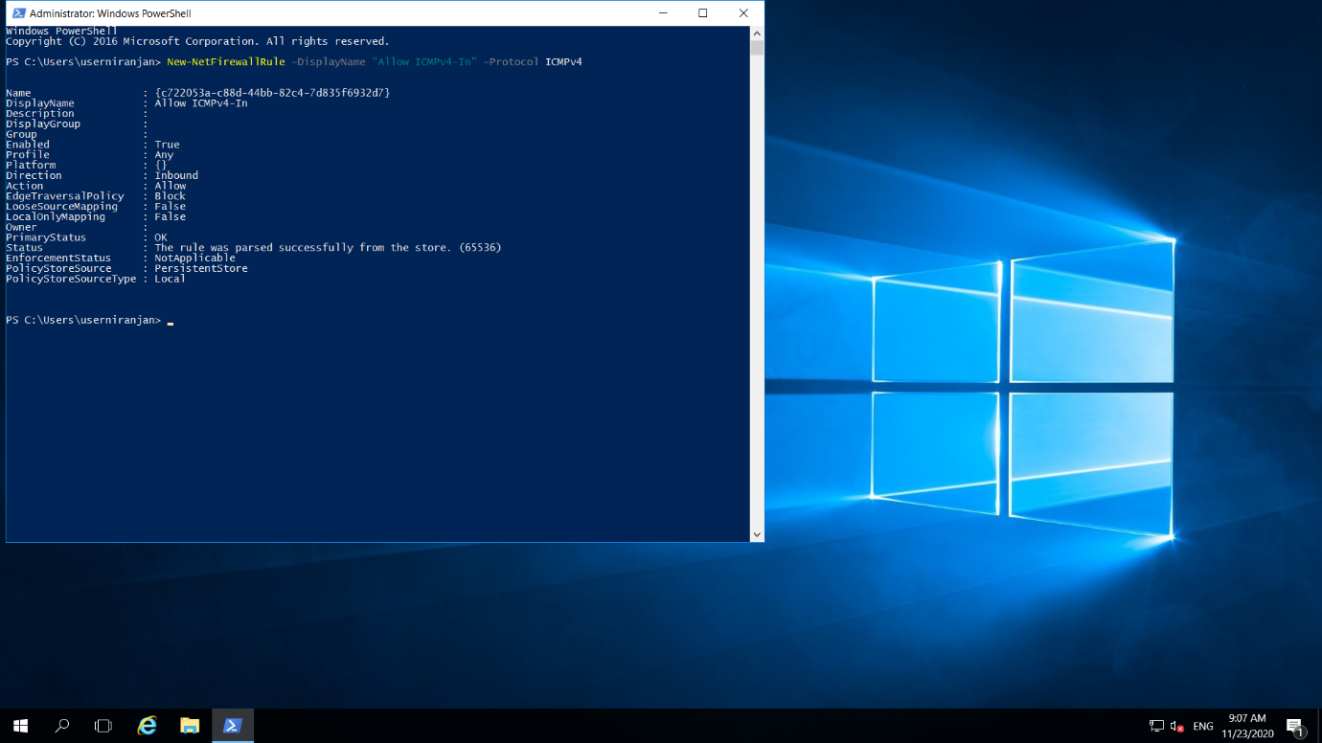Step30:Allow ICMP Port Using Powershell in VM1.

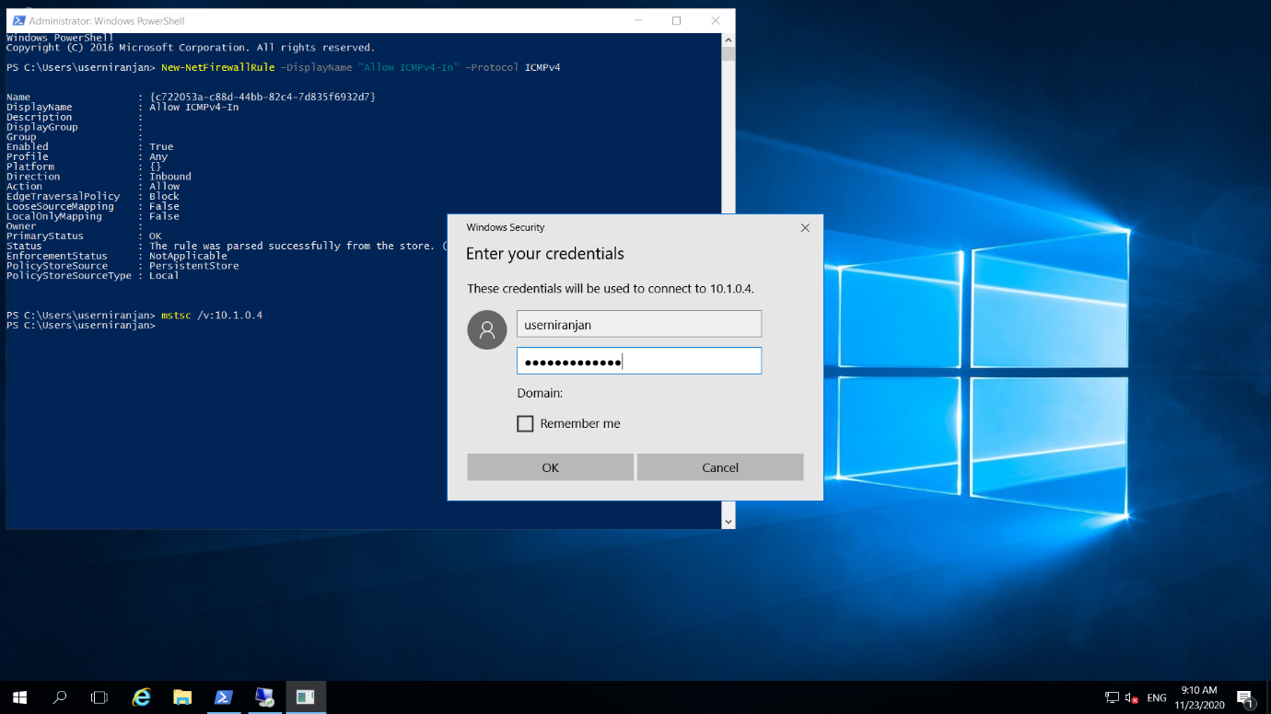Step31:Connecting To VM2 From VM1 .using Powershell Command (mstsc /v:10.1.0.4)

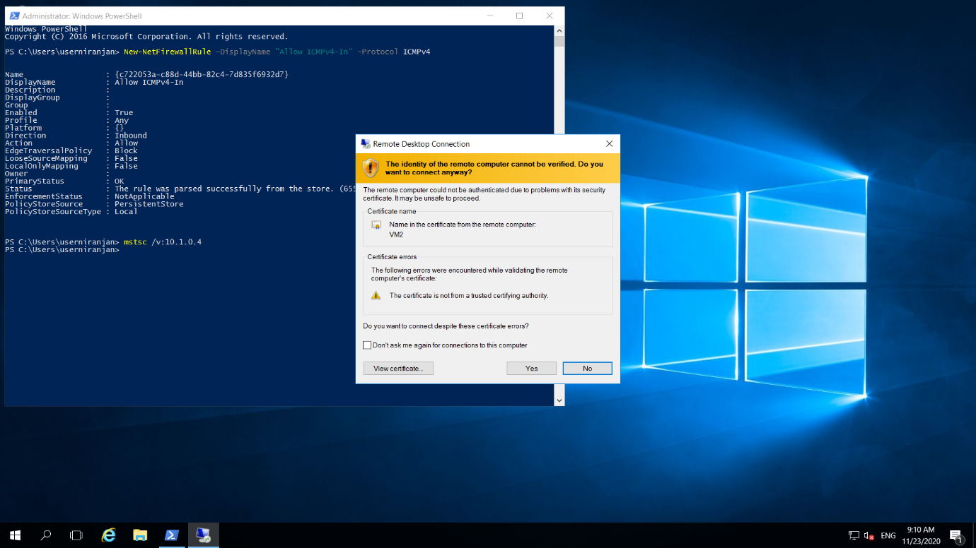Step32:Remote Desktop certificate.

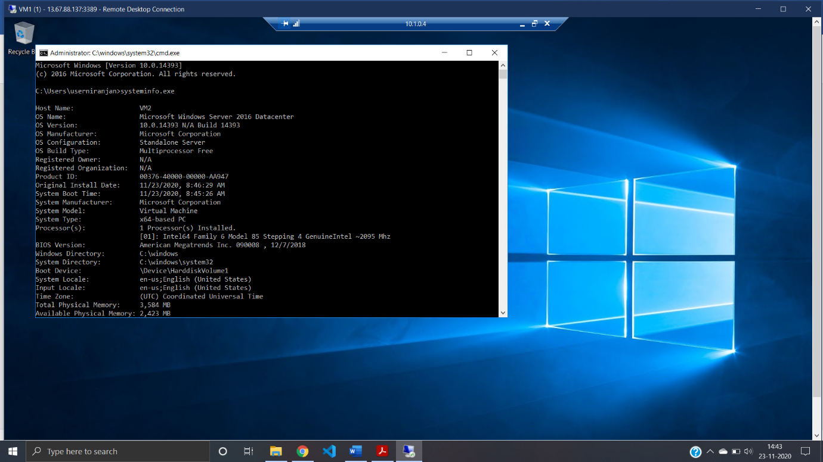Step33:Success Fully Logon To VM2

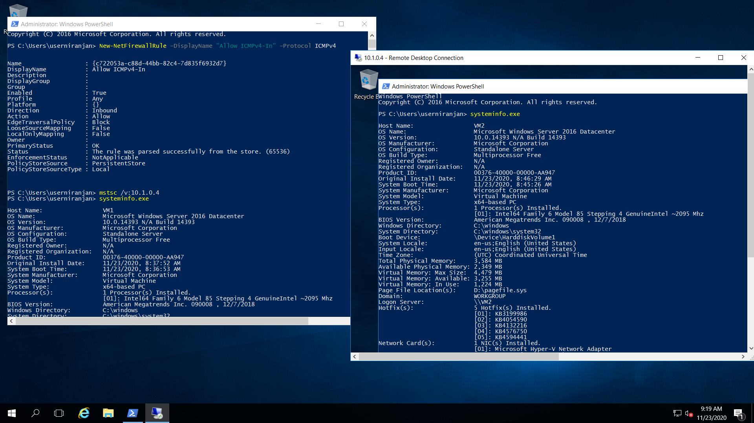Step34:Hence Successfully Done With Connecting VM1 And VM2

**Adding Disk To VM1**

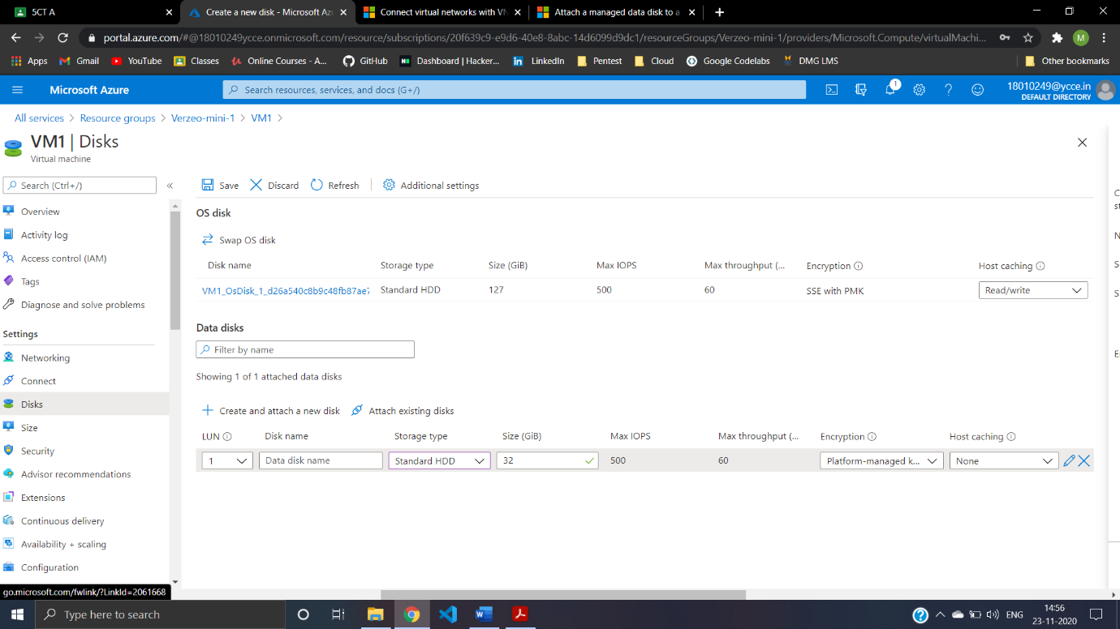Step35:Creating Disk

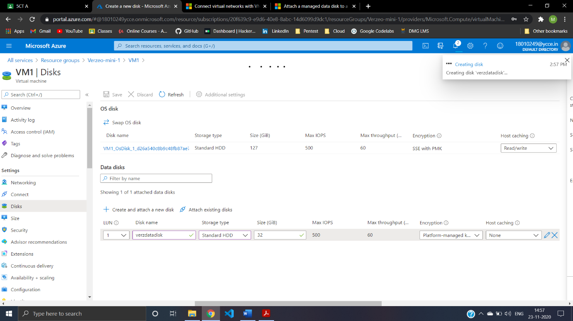Step36:Saving The Disk Changes

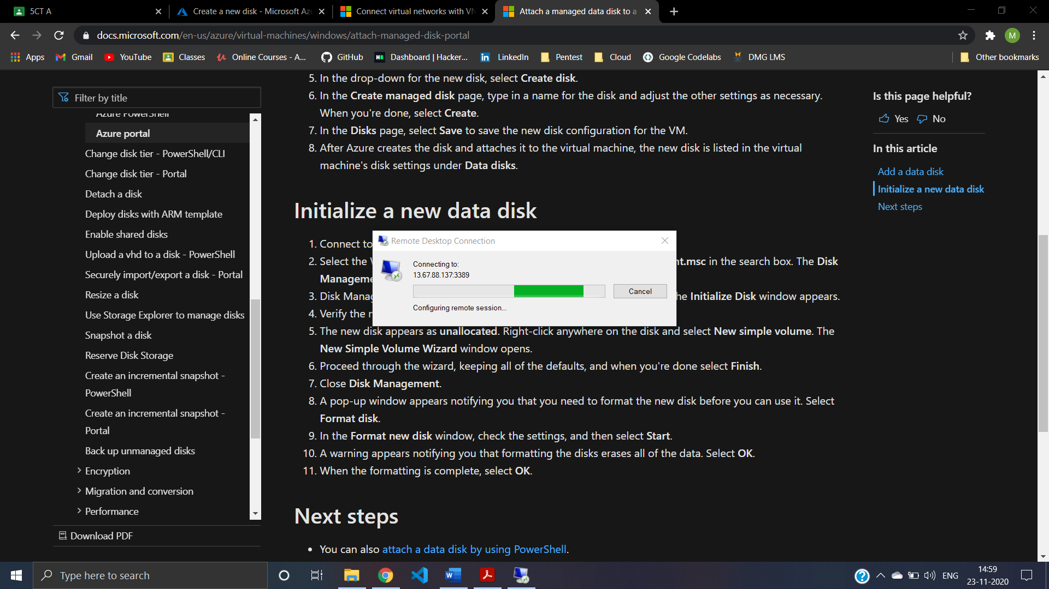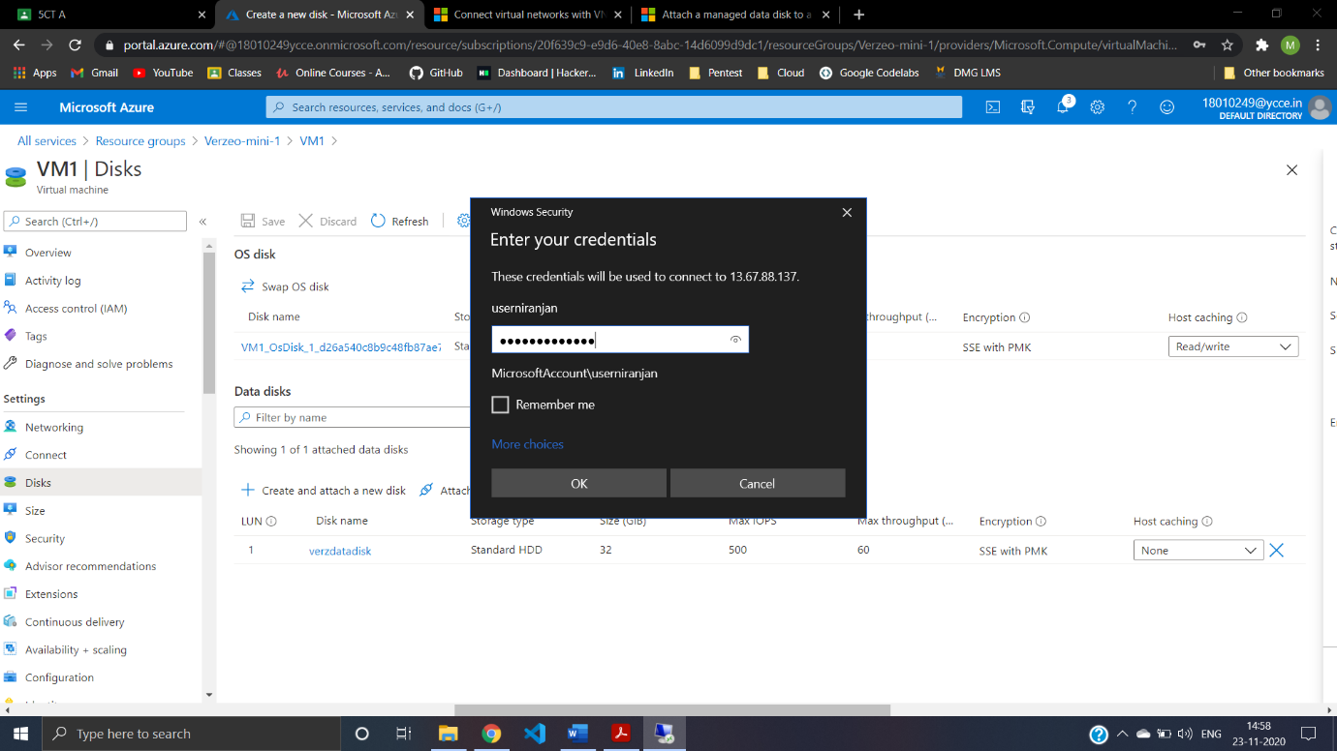Step37:Connecting To VM1 using RDP port.

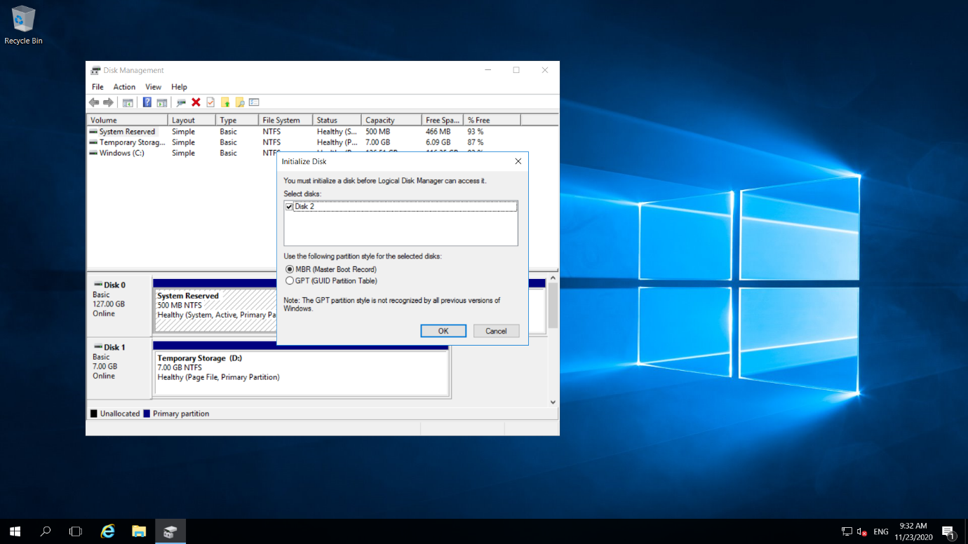Step40:Adding Unallocating New Disk To VM1

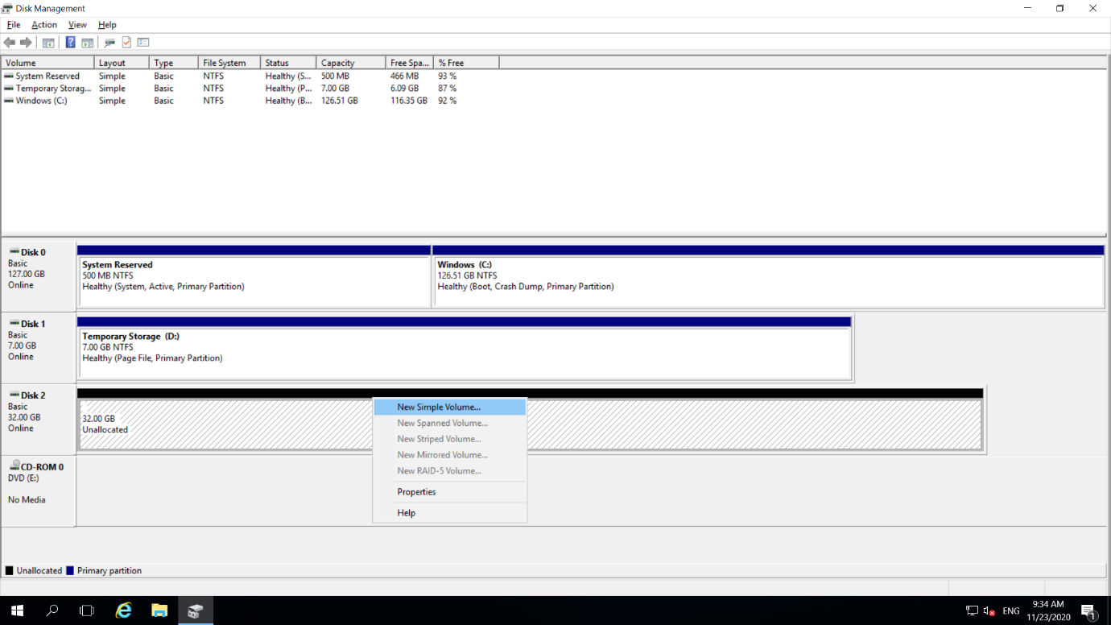Step41:Allocating Disk Steps

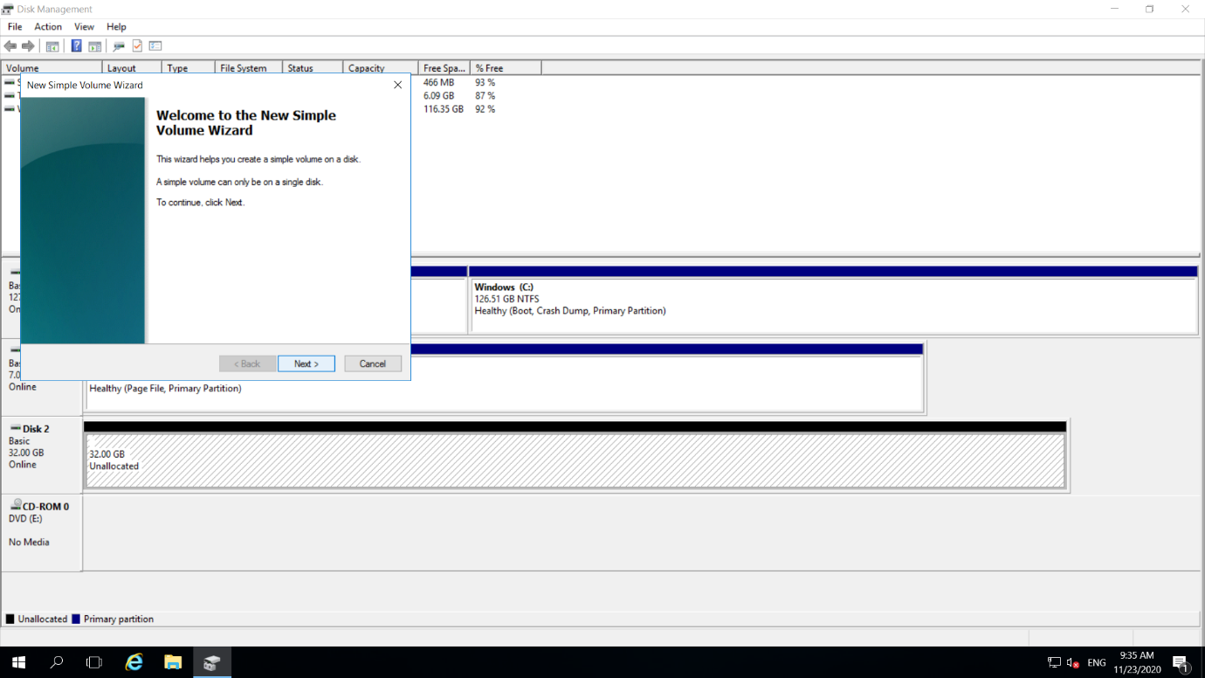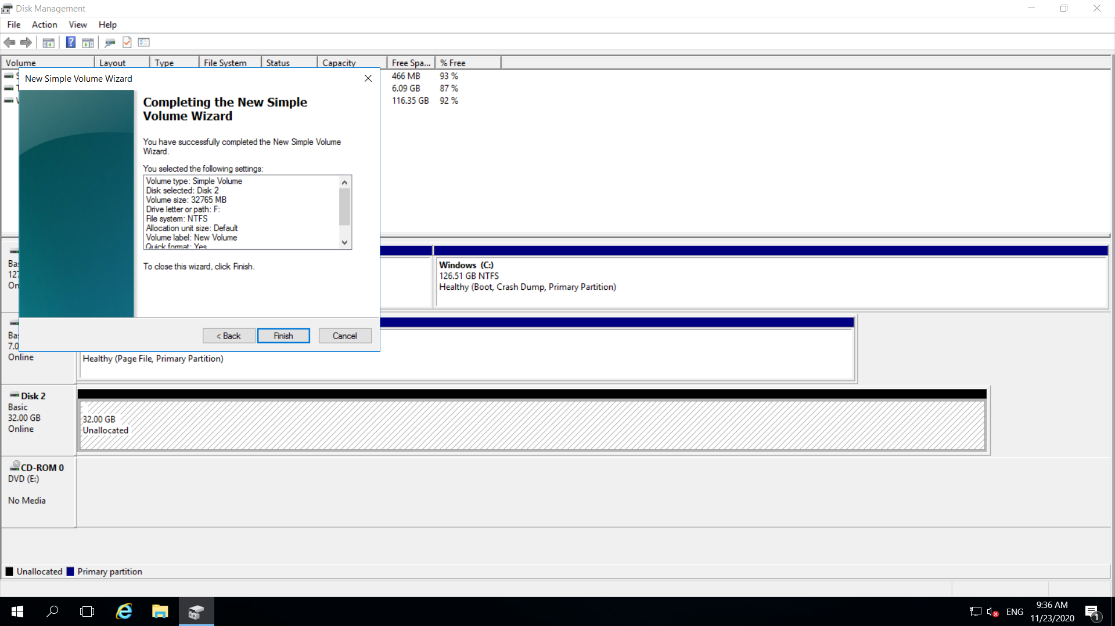

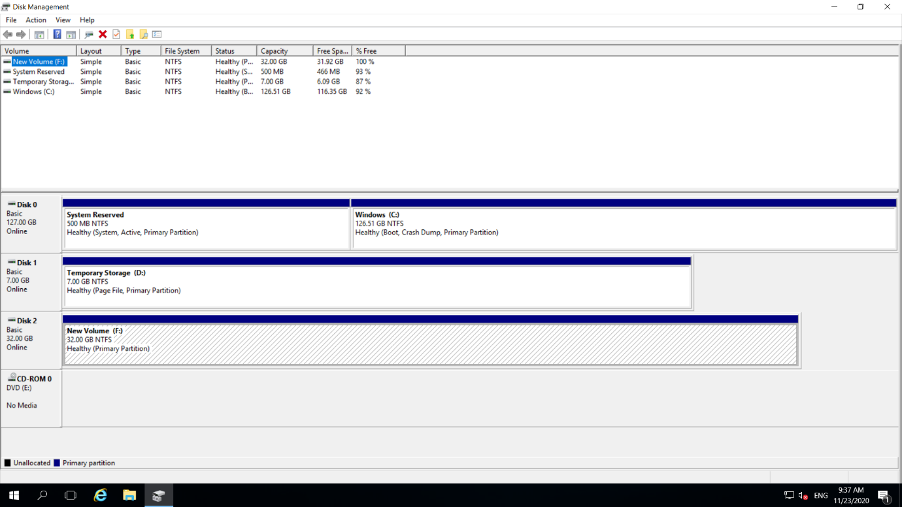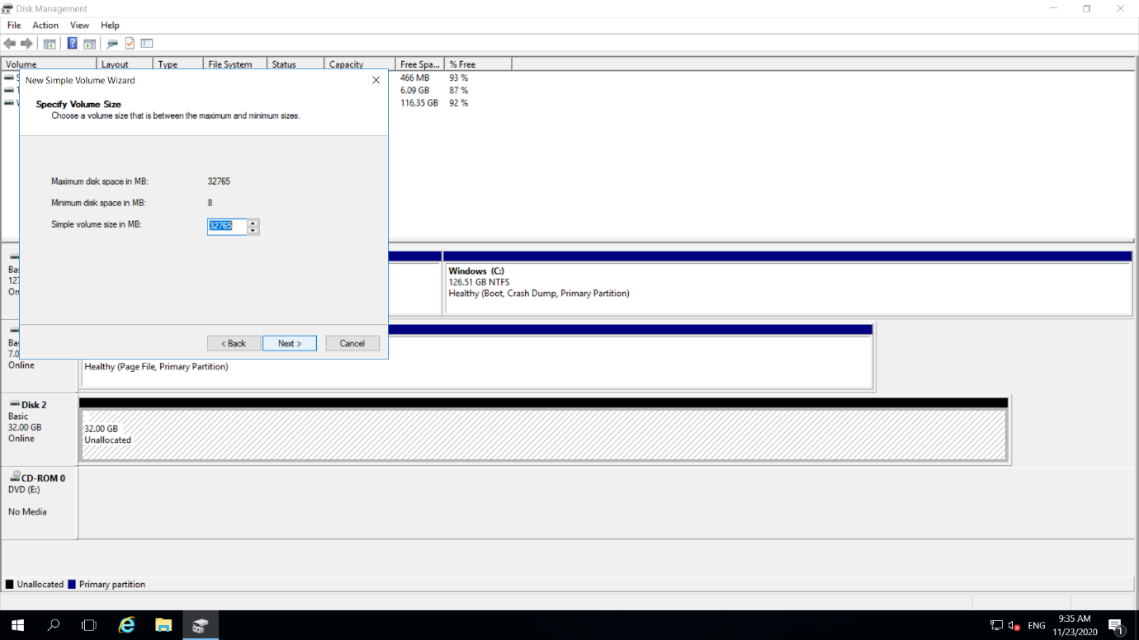

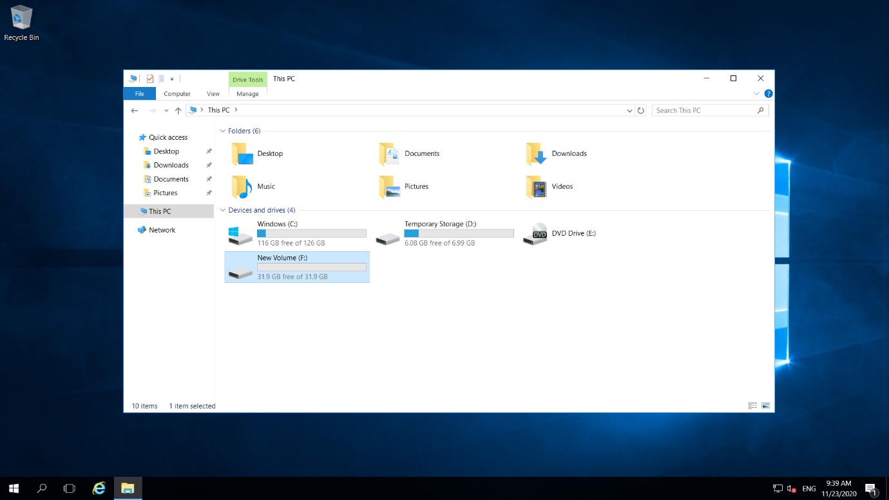Step42:Done with Adding Disk

Step43:Resources

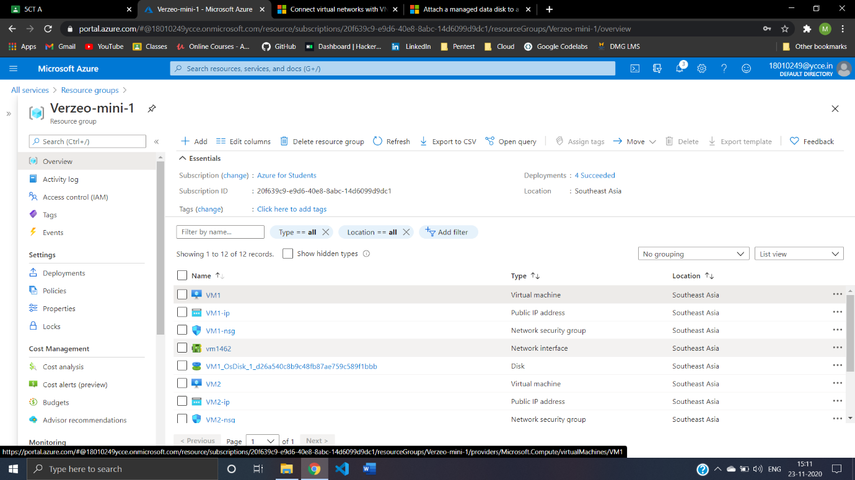

Step44:Wrapping -Up Deleting Resources

